FIFTEEN PUZZLE

23CSE211 - Design and Analysis of Algorithms

CB.SC.U4CSE24702 | ABHINAV A
CB.SC.U4CSE24743 | KRISHNA TEJA
CB.SC.U4CSE24719 | HARSHA VARDHAN
CB.SC.U4CSE24766 | RAHUL REDDY

1: INTRODUCTION:
The 15-Puzzle is a classical combinatorial optimization problem consisting of a 4×4 grid containing fifteen numbered tiles and one empty space. The objective is to transform an arbitrary initial configuration into the goal configuration by performing valid tile slides.
The state space of the 15-Puzzle is extremely large (16! possible configurations), making exhaustive search computationally infeasible. Therefore, efficient problem decomposition and heuristic-guided decision-making strategies are required.
In this implementation, the puzzle is modelled as an implicit state-space graph. Each board configuration represents a vertex, and each valid tile movement represents an edge.
Unlike the previous BFS-based approach, the current solution applies a Divide and Conquer strategy combined with Greedy heuristic evaluation. The puzzle is decomposed row-wise into subproblems. Each row is solved sequentially while preserving previously solved rows through a locking mechanism. This progressively reduces the effective search space and improves convergence toward the goal state.
The primary objective of this implementation is to demonstrate how Divide and Conquer principles can be adapted to heuristic search problems in interactive environments.

2: RULES OF THE 15-PUZZLE:
Rules of the 15-Puzzle
- The puzzle consists of a 4×4 grid with tiles numbered 1 to 15 and one empty space.
- A tile can be moved only if it is adjacent (up, down, left, right) to the empty space.
- The empty space swaps position with the selected tile.
- The goal is to transform the initial configuration into the goal configuration

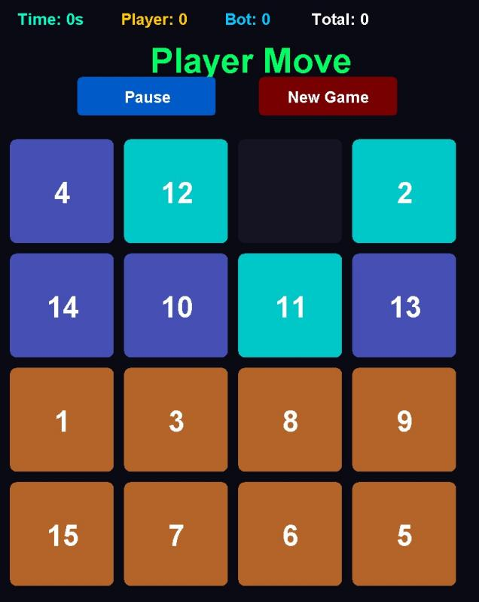

BEFORE SOLVING

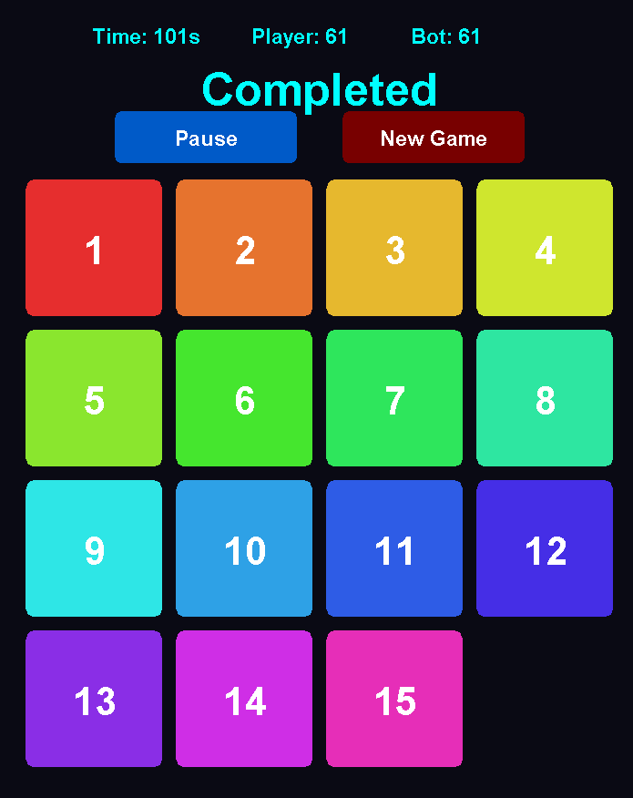
AFTER SOLVING

3. ALGORITHM:
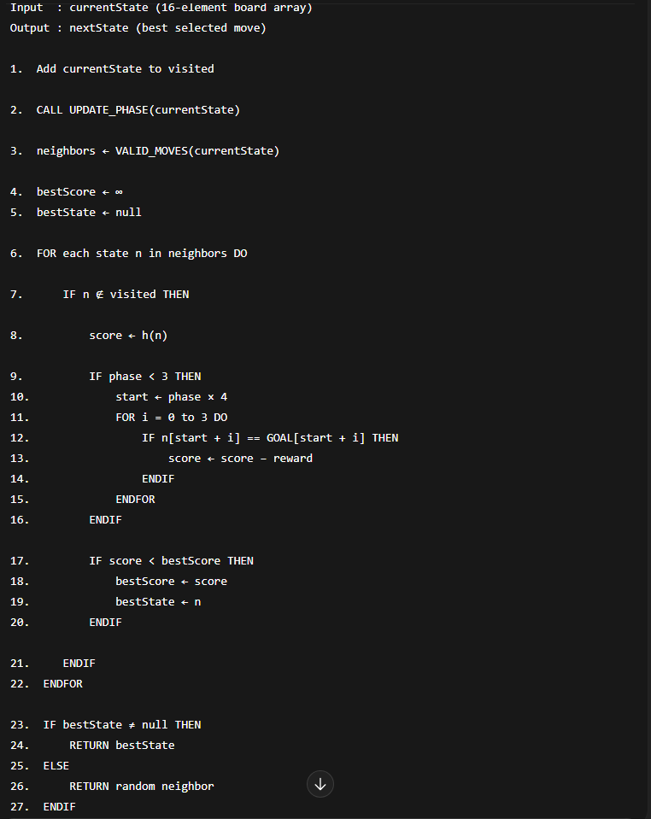

DIVIDE STEP-


SUBPRBLEM CHECK
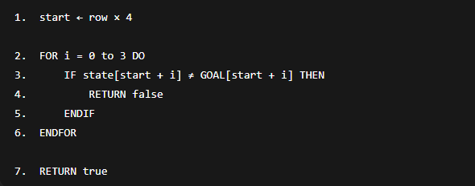

4. Termination Condition
The algorithm terminates when the current board configuration matches the goal configuration.

5.PROOF OF CORRECTNESS

Lemma 1: All Generated Moves Are Valid
From any current state, only legal tile moves are generated. Therefore, every transition preserves puzzle validity.

Lemma 2: The Algorithm Progresses Toward the Goal
The Manhattan distance heuristic estimates closeness to the goal state. At each step, the algorithm selects the state with the smallest heuristic value, ensuring progress toward the goal.

Lemma 3: Solved Subproblems Remain Fixed
Using row locking, once a row matches the goal configuration, it is preserved and not disturbed by future moves.

Lemma 4: The Algorithm Terminates
The state space of the puzzle is finite. Visited states are tracked to prevent cycles, and the algorithm stops when the goal configuration is reached.

Final Theorem:-
From the above lemmas, if a solution exists, the algorithm will eventually reach the goal configuration. Therefore, the algorithm is correct.
Proof of Correctness Using Mathematical Induction:-
Base Case (Phase 0)
Initially, no rows are solved.
During Phase 0, the algorithm works only on the first row (tiles 1,2,3,4).
It rearranges the tiles until the first row matches the goal configuration.
When Phase 0 completes, Row 0 is correctly arranged and locked.
Therefore, the invariant holds for k = 1.
Inductive Hypothesis
Assume that at the beginning of Phase k:
Rows 0 to k−1 are correctly arranged and fixed.
Inductive Step
During Phase k:
The algorithm operates only on the unsolved portion of the board.
It does not disturb rows 0 to k−1 because they are locked.
It rearranges the tiles in row k until they match the goal configuration.
After Phase k completes, Row k is correctly arranged and locked.
Therefore, rows 0 to k are correct.
Thus, the invariant holds for k + 1.
Conclusion
By mathematical induction, after Phase 3 completes, all rows are correctly arranged.
Therefore, the board equals the Goal state.
Hence, the algorithm is correct.

6. LIMITATIONS OF ALGORITHMS:

- Does not guarantee optimal solution.
- Greedy heuristic may cause local minima.
- No backtracking once a row is locked.

7. Time Complexity

Let:
- b = branching factor (≤ 4)
- d = number of moves
Without decomposition, search complexity approaches O(b^d).
With Divide & Conquer:
- Search space reduces after each row is solved.
- Effective branching factor decreases per phase.
- Practical performance significantly improves.
Worst case remains exponential, but practical performance is efficient due to phased restriction.

8. Conclusion
The current implementation applies a structured Divide and Conquer approach to the 15-Puzzle problem.
The puzzle is decomposed into row-level subproblems, each solved sequentially using Manhattan heuristic-based greedy selection. A row-locking mechanism ensures partial solutions are preserved, reducing effective search complexity.
This approach demonstrates:
- State-space modeling
- Heuristic evaluation
- Progressive constraint-based reduction
- Divide and Conquer adaptation in search problems
Although the algorithm does not guarantee optimality, it provides an efficient and academically strong solution that clearly illustrates Design and Analysis of Algorithms principles.

